LEADERSHIP WHITEPAPER
AI Without Guardrails Is Innovation on a Cliff
Building Safe, Trustworthy, and Scalable Enterprise AI
A perspective from company leadership on why governance is the foundation, not the obstacle, of responsible AI adoption.

Executive Summary
Generative AI has moved from experimentation to execution. Across every industry, the conversation inside boardrooms has shifted from “what can AI do?” to a harder and more consequential question: “can we trust AI to do it responsibly, at scale, in front of our customers, our regulators, and our employees?”
Our answer is guardrails. AI guardrails are the preventive and detective controls that monitor, filter, and guide AI behavior, ensuring every system we deploy is reliable, ethical, and aligned with both business objectives and human values. They are not a constraint on innovation. They are the structural support that allows innovation to move faster, with confidence, instead of grinding to a halt after the first costly mistake.
This whitepaper outlines what AI guardrails are, how they function within our AI systems, the business impact of getting them right, and the best practices we are adopting as an organization. It is written for our leadership team, our board, and our partners who are evaluating how we build and deploy AI responsibly.
Guardrails don’t limit AI. They make AI limitless - by making it something the business can actually depend on.

The Innovation-Trust Tradeoff
Every technology inflection point creates the same temptation: move fast, capture the advantage, and worry about the guardrails later. AI is no exception, and the stakes are higher, because AI systems make decisions, generate content, and interact directly with customers and employees at a speed and scale no previous technology has matched.
The image of a car navigating a cliffside road captures the moment we are in as an industry. The road, our AI capability, has never been more powerful or more direct. Without a barrier, one wrong turn is catastrophic: a hallucinated fact in a customer-facing answer, a leaked piece of confidential data, a biased output that damages trust built over years. With the right barrier in place, the same road becomes something the business can travel at full speed, with confidence.
That barrier is the guardrail. Our position as leadership is simple: guardrails are not a checkbox for compliance. They are a competitive advantage - the difference between organizations that can only demonstrate what AI can do, and organizations that can prove it can be trusted to do it.

What Are AI Guardrails?
AI guardrails are a set of preventive and detective controls that monitor, filter, and guide AI behavior to prevent harm, ensure compliance, and maintain trust. They operate across five core dimensions of responsible AI:
- Prevent Harm - blocking unsafe, toxic, or biased content before it reaches an end user.
- Ensure Compliance - aligning AI output with legal, regulatory, and internal policy requirements.
- Maintain Accuracy - reducing hallucinations and fact-checking critical or high-stakes responses.
- Protect Privacy - preventing the leakage of sensitive, personal, or confidential data.
- Build Trust - creating consistent, reliable experiences that customers and employees can depend on.
Together, these dimensions define the operating boundary within which our AI systems are allowed to act, not to slow them down, but to keep every interaction inside the zone of acceptable, trustworthy behavior.

How AI Guardrails Work
Guardrails are not a single filter bolted onto a model. They form a pipeline, screening what goes into the system and what comes out of it, at every step of an interaction:

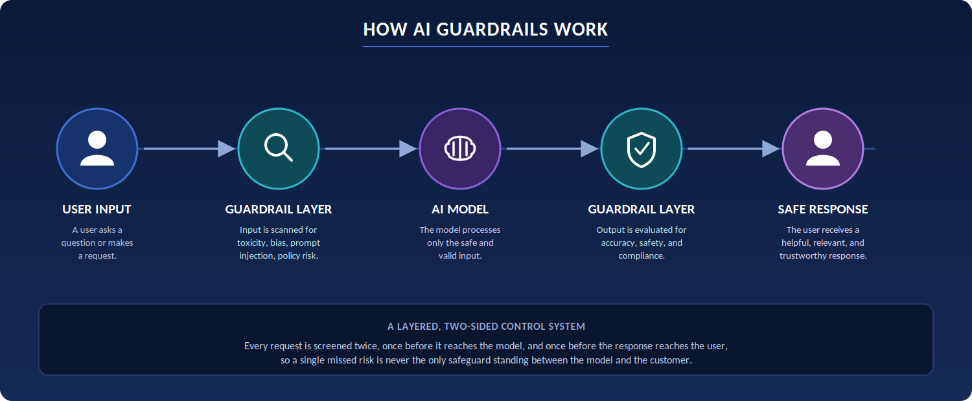
Stage | What Happens
1. User Input | A user submits a question, prompt, or request to the AI system.
2. Guardrail Layer (Input) | The request is screened for toxicity, bias, prompt injection, and policy violations before reaching the model.
3. AI Model | The underlying model processes only the input that has passed screening.
4. Guardrail Layer (Output) | The model's response is evaluated for accuracy, safety, and compliance before release.
5. Safe Response | The user receives an answer that is helpful, relevant, and trustworthy.

This layered approach means a single point of failure is never the whole story. If a harmful input slips past the first check, the output layer still evaluates the model’s response before it ever reaches the user.

Types of Guardrails
In practice, we implement guardrails across four categories, each addressing a different point of risk in the AI lifecycle:
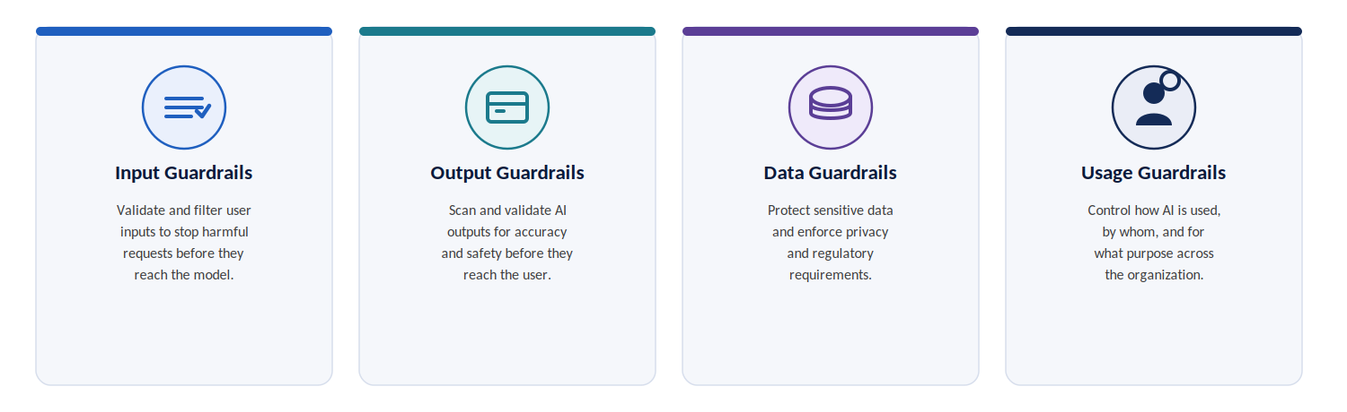
Guardrail Type | Function
Input Guardrails | Validate and filter user inputs to stop harmful or malicious requests before they ever reach the model.
Output Guardrails | Scan and validate AI-generated responses for accuracy, safety, and policy compliance before they reach the user.
Data Guardrails | Protect sensitive and confidential data, enforcing privacy and regulatory requirements throughout the AI pipeline.
Usage Guardrails | Govern how AI is used, by whom, for what purpose, and within what limits of authority.

Real-World Business Impact
Guardrails are frequently framed as a cost center or a compliance obligation. In our experience, the opposite is true - these controls are directly linked to measurable business outcomes:
- Reduced reputational risk and financial exposure from AI-generated errors or policy violations.
- Responsible AI adoption at scale, across business units, without a proportional increase in oversight burden.
- Strengthened trust with customers and employees, who increasingly expect AI interactions to be safe and transparent.
- The confidence to innovate faster, because teams are not forced to choose between speed and safety.
The organizations that will lead in this next phase of AI adoption will not necessarily be the ones with the largest models. They will be the ones with the strongest guardrails - the ones who can demonstrate, not just claim, that their AI can be trusted.

Best Practices We Are Adopting
- Define Clear Policies - establish explicit rules for what AI is allowed to do, what is restricted, and what is strictly prohibited.
- Apply Layered Controls - combine multiple guardrails across the full AI lifecycle rather than relying on any single safeguard.
- Monitor Continuously - track, detect, and respond to emerging risks as models, data, and usage patterns evolve.
- Keep Humans in the Loop - preserve human oversight and final judgment for high-impact or high-ambiguity decisions.
These practices are not static. As our AI systems and the regulatory landscape evolve, our guardrail architecture will evolve with them, reviewed and strengthened on an ongoing basis, not implemented once and left in place.

The Leadership Takeaway
AI guardrails are not a checkbox. They are a competitive advantage.
For leadership, the mandate is clear: guardrails empower our organization to unlock the full potential of AI while remaining safe, compliant, and trustworthy. They are the mechanism by which we say yes to AI adoption with confidence, rather than saying yes and hoping for the best.
The future belongs to organizations that innovate fast, but govern smarter. Our commitment, as leadership, is to build the guardrails today so that we can lead with trust tomorrow.

Conclusion
AI without guardrails is innovation on a cliff, exhilarating until the moment it isn’t. Our approach is to build the barrier alongside the road: to pursue every opportunity AI presents while ensuring that opportunity never comes at the cost of safety, compliance, or trust.
We invite our teams, partners, and customers to hold us to this standard, and to see our investment in AI guardrails not as a limitation, but as the clearest signal of how seriously we take our responsibility to get this right.

About the Author

Prakash Nagaraj
Head of Service Delivery
Quadrant Technologies
5020, 148th Avenue NE, Suite-250, Redmond, WA-98052

Direct: +1 425 296 1122
Email: prakash@quadranttechnologies.com
LinkedIn: linkedin.com/in/prakash-nagaraj/

